# Lab 7: Color Array

Academic Honesty

* The work you turn in is to be your work, not copied from someone else, from the web, or generated by a program.
* Never allow anyone access to your files.
* Never give anyone your password.
* Never share your USB memory or email your files to anyone else.
* Never give anyone a printed copy of your file or an electronic copy.
* Never allow anyone to copy your work.

Purpose

This lab will let us practice using the random generator, graphics, lists, and loops

## Functionality

* You will first ask the user how many shapes they want to make
* You will create the shapes which each have a:
  + Random location (within the window)
  + Random color (picked from a list you create)

## Implementation

* You will use a loop to create the correct number of shapes
* You will randomly draw either a car or truck for each shape.
* Sample look of the car and truck are shown in the sample.

## Sample Program

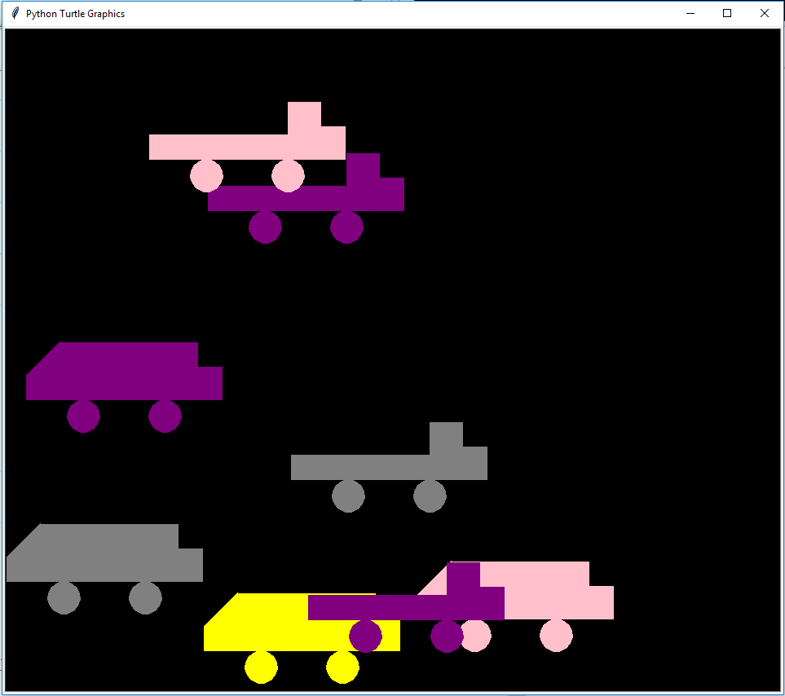

## Submitting your files

* Copy your .py file and move it to your X:\101Labs directory for grading.
* Make sure your file is named Lab7XY.py where XY are your initials
* Print your code, and submit it to your lab instructor at the beginning of your next lab class.

## Grade Breakdown

|  |  |
| --- | --- |
| **Points** | **Expectation** |
| 10% | Comments, listing program, your name, and explaining the code |
| 20% | Correctly setting up the for loop |
| 20% | Generating random location, and size |
| 20% | Generating random colors using a list |
| 20% | Creating the random circles |
| 10% | Input and Output for user |